Art
Yr 1 | Yr 2 | Yr 3 | Yr 4 | Yr 5 | Yr 6
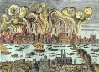  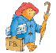  Let’s Explore London  Cycle 1 Autumn Term |  | 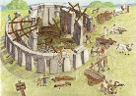  Meet the Flintstones  Cycle 1 Autumn Term |  | 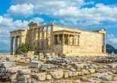  Greece Lightning  Cycle 1 Autumn Term
Drawing  Create a landscape of the Great Fire of London, looking at etchings of the time  Explore the use of line and shape, using a variety of tools, inc. pencils, rubbers, felt tips, charcoal, ballpoints, chalk  Painting  Create a painting of the light in dark. Looking at the work of Leonid Abremov  Light and dark colours – looking at tone, applying thick paint |  | Cave art and stone-age paintings  Drawing  Experiment with different grades of pencil and other implements on a variety of surfaces, including stone  Painting  Identify the use of colour from natural materials. Make observations of cave paintings and reproduce – compare with Picasso’s bull paintings  3D  Design and make a simple pinch pot |  | Greek Pottery  Drawing  Study the shape and designs of Greek pots and make a series of observational drawings.  Draw figures from life in the style of those on Greek pottery.  Manipulate and experiment with the elements of line and pattern  3D  Design and make a Greek pot using the coil method.
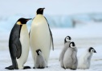  Poles Apart  Cycle 1 Spring Term |  | 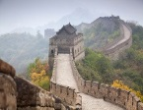  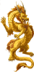  China  Cycle 1 Spring Term |  | 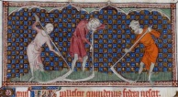  Invaders  Cycle 1 Spring Term
Painting  Creating an image using cold colours  Practice mixing different tones of white and blues, looking at Claude Monet’s snow scenes.  Mixed Media  Use a range of art techniques to create artwork depicting the Northern Lights e.g  Graffito  Pastels |  | Painting  Chinese Water-colour paintings  Learn how to use stretched paper and Chinese brush strokes to create Chinese-style images  3D  Chinese Dragons  Design and make a Chinese dragon using wire and tissue paper. |  | Drawing / Painting  A Study of Medieval Illuminations  Use a sketch book to collect examples of illuminations. Explore the use of pattern and colour and use of gold leaf.  Make a study of how medieval monks represented the human figure – how does this compare to the figures on Greek pots?  Create an illustration based around a character or scene from a medieval story.

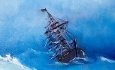  Seasides and Shipwrecks  Cycle 1 Summer Term | 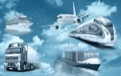  Transport  Cycle 1 Summer Term | 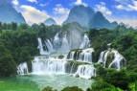  Wild Water  Cycle 1 Summer Term
Drawing  Develop use of line, tone, pattern and texture to sketch a variety of shells.  Textiles  Create a seascape collage using fabrics / wools  Explore, sort and select fabrics that represent the colours and effects of the sea.  Learn how to apply simple stitching to fabrics. Combine fabrics and stitching techniques to create a seascape image. | Drawing  Using the work of famous artists (e.g Van Gogh, Hobbema, Hockney, look at the use of perspective in images of roads. Use photographs of roads in Norfolk to create a drawing showing perspective.  Painting  A study of ‘Rain, Steam and Speed’ by Turner. Experiment with paint to replicate the effects of weather and movement. Using knowledge of perspective, create a painting showing a mode of transport moving from the background into the foreground. | Drawing and Painting  Impressions of Water  Look at a range of Impressionist artists who have represented water through art e.g Monet, Renoir. Seurat. Use a variety of media – paint, pastels to reproduce some of these effects.  Experiment with acrylic pour and marbling techniques.
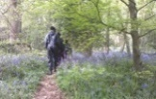  Memory Box  Cycle 2 Autumn Term | 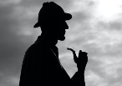  Crime and Punishment  Cycle 2 Autumn Term | 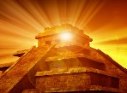  The Mayans  Cycle 2 Autumn Term
Drawing  E H Shepard – Winnie the Poo  Study E H Shepard’s use of line and shade in his drawings for the Winnie the Poo books. Look at the different positions of the toys – make observatinal still-life drawings using real toys.  Painting  L. S. Lowry  Look at how Lowry created his images of children / people. Use paint to create our own people. Create a background for a school playground and paint people onto the foreground. | Portraiture  Drawing  Research the work of the courtroom artist Priscilla Coleman. Learn how to use pencil and charcoal to produce faces from different angles.  Create artwork using chalks and pastels in the style of a courtroom artist. | Mayan Calendars  Drawing  Look at the circular Mayan calendars and the use of patterns and design within concentric circles. Re-create a calendar using concentric circles and black pen, focussing on line and pattern.  3D  Practise imprinting patterns and lines onto a tablet of clay. Also explore how to appy cut-out shapes of clay using a slip. Using information gathered from drawing project, roll out a circle of clay and use tools to create a Mayan-style calendar onto the surface.
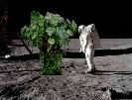  Pioneers  Cycle 2 Spring Term | 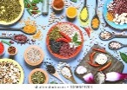  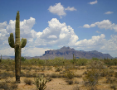  Extreme Survival  World Kitchen  Cycle 2 Spring Term | 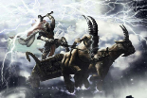  Rule Britannia  Cycle 2 Spring Term
ICT  Space pictures  Look at a variety of images (photos and paintings) of space and learn how to use the various tools on 2Simple to replicate some of these effects.  Put together a series of images to create our own electronic space painting. | Arcimboldo  Drawing  Use a range of sketching and drawing techniques to draw fruits, vegetables and flowers from real life, looking at position, line and tone.  Collage  Study the work of Arcimboldo and identify how his work has been created. Collect a variety of images of fruit, vegetables and flowers, cut out and arrange into a portrait using a decoupage style. | The Bayeux Tapestry  Drawing  Make studies of the Bayeux tapestry, identifying people, horses, boats etc.  Textiles  Explore stitching techniques using tapestry canvas. Design a simple scene from the Battle of Hastings and transfer onto the canvas – stitch to produce a tapestry.
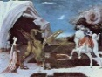  Dragons, Castles and Kings  Cycle 2 Summer Term | 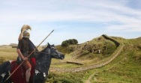  Roman Rule  Cycle 2 Summer Term | 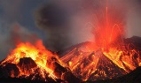  Disaster  Cycle 2 Summer Term
3D  Following the study of Dragon anatomy, make a clay model of a dragon, learning how to mould and join clay using slip. | 3D  Painting  Roman Frescoes  Look at how the Romans painted animals. Make sketches of animals in different positions using line and tone.  Practise using paint to create levels of tone to give 3D impressions.  Apply a layer of plaster to small canvasses and use watered-down acrylics to paint a Roman-style fresco of an animal.  Roman Mosaics  Make a study of Roman mosaics and re-create using a variety of materials – starting with paper and developing into ceramic tiles. | Drawing  Using the figures from Pompeii, use charcoal to sketch each other in mid-action and in differing positions.  3D  Learn how to mould wire into figures and apply Modroc to create Pompeii – style figures.

